**WEEK-6**

**REACT**

**3.ReactJS-HOL**

**Create a React project named “scorecalculatorapp”**

**CODE:**

**Step 1: Create React App**

In terminal or command prompt, run:

**npx create-react-app scorecalculatorapp**

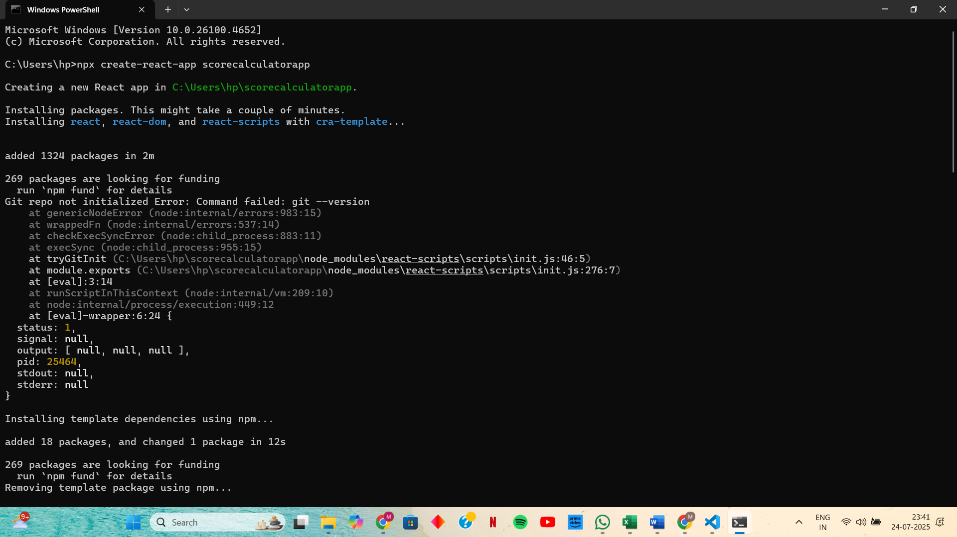

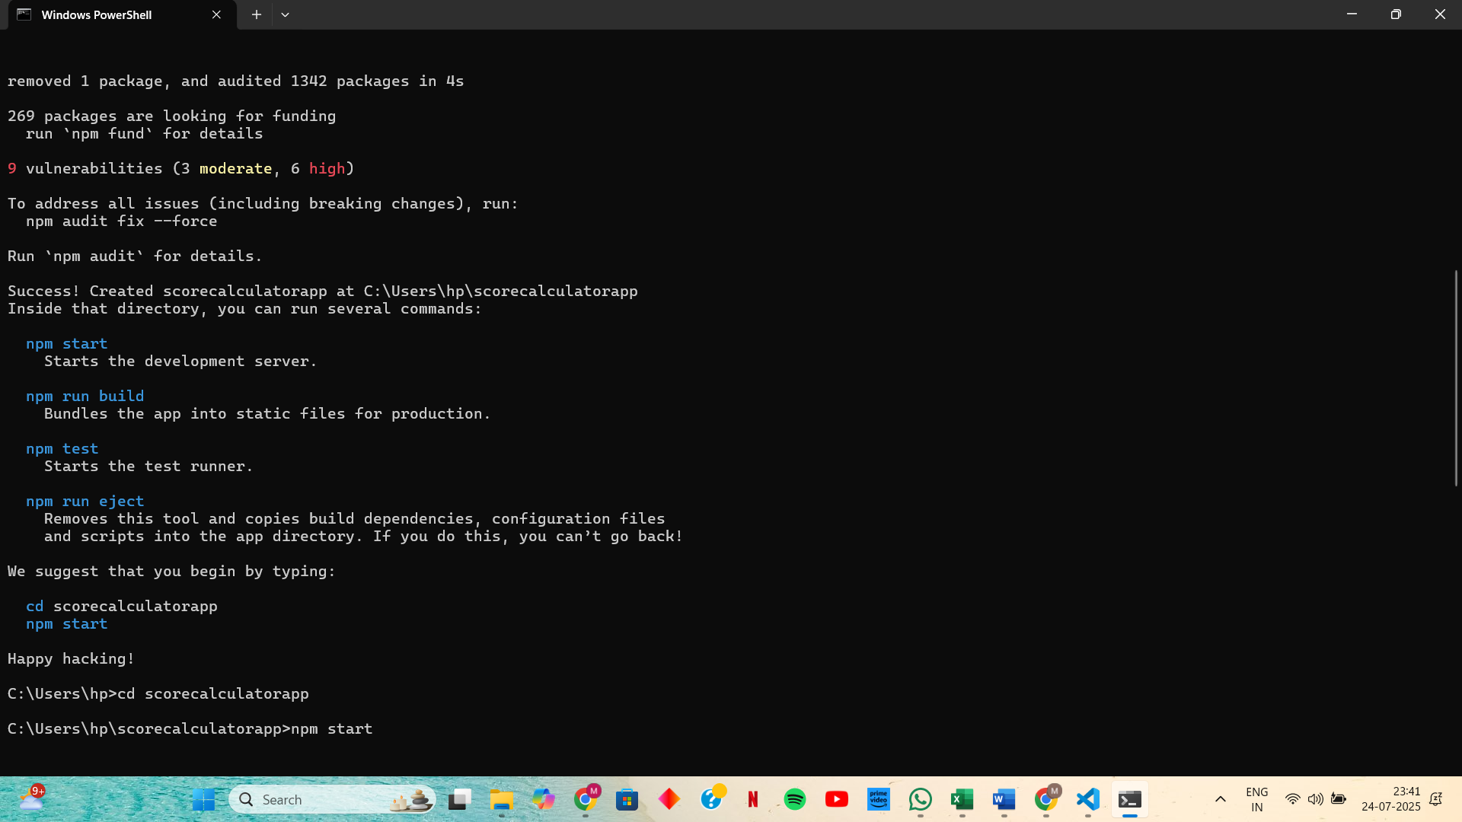

**Step 2: Navigate to the project folder : cd scorecalculatorapp**

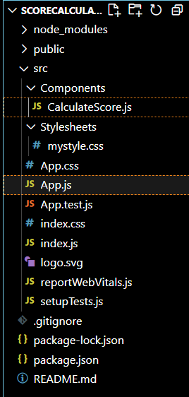

**Step 3: Open project in VS Code and Create Components folder in src folder**

**Step 4: Inside Components, create a file named CalculateScore.js**

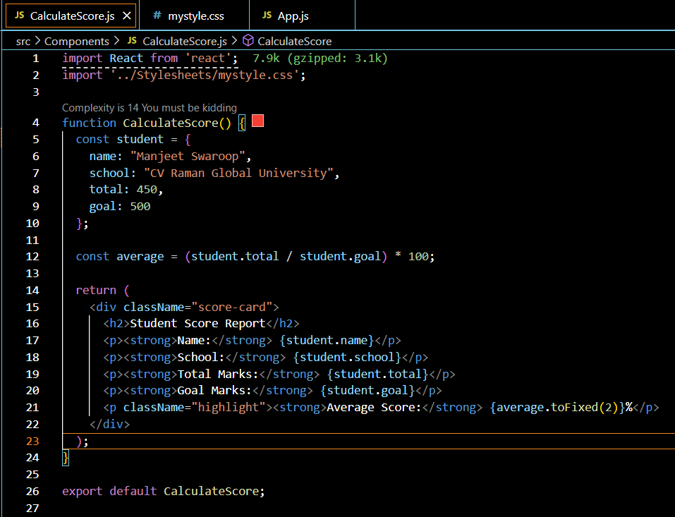

**Step 5: Create Stylesheets folder Under src and Inside Stylesheets, create a file named: mystyle.css**

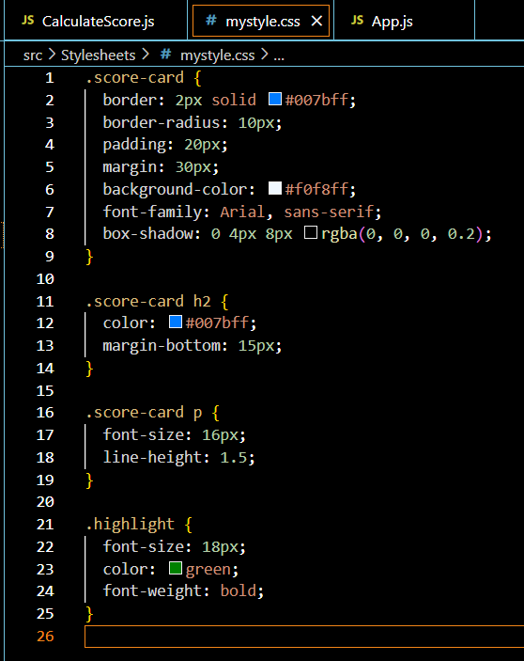

**Step 6: Edit App.js to render your component in src/App.js**

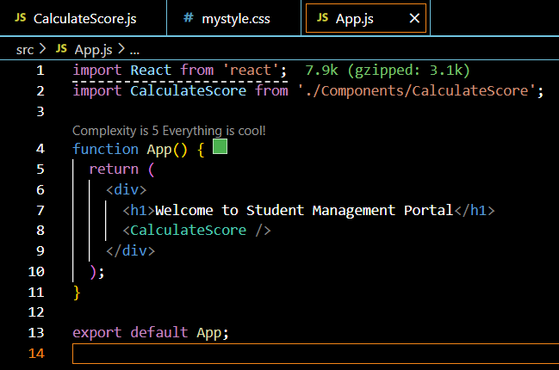

**OUTPUT:**

